



Registration Guide and List of Favorite Certificates

- Operators Exempted from certification under Article 35(8) of Regulation (EU) 2018/848
- Operators Exempted from notification under Article 34(2) of Regulation (EU) 2018/848
- Certified Operators

October 2024



Requesting an exempted role:
After having created an EU-Login account, you will need to try to access TRACES at least once for your user account to become active.
Using the link https://webgate.ec.europa.eu/tracesnt/login , enter your credentials and you shall be redirected to the following screen where you shall be asked to select your purpose of registration:
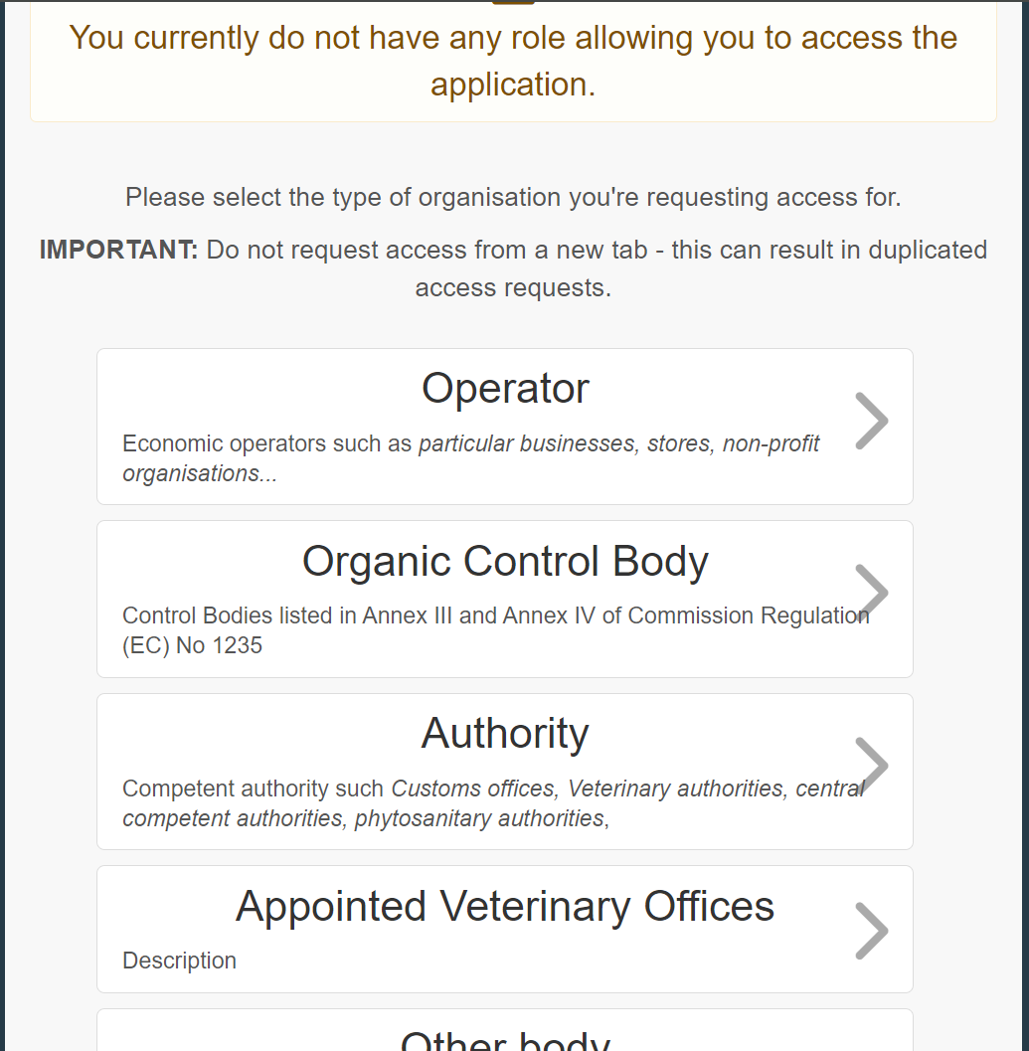
Proceed by choosing Operator either by searching for an existing one:
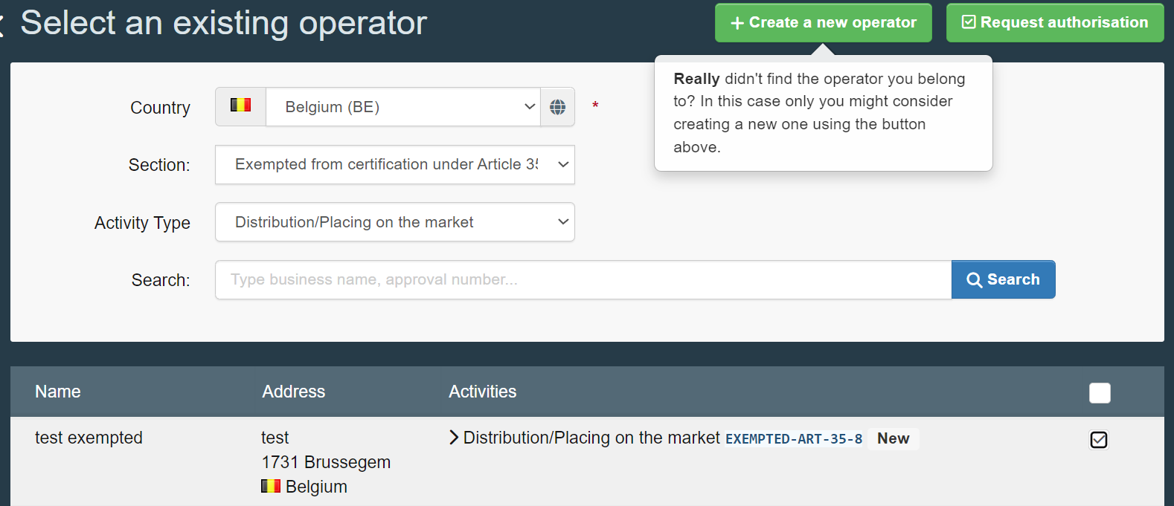

Or link to an operator with a valid Organic Operator Certificate:
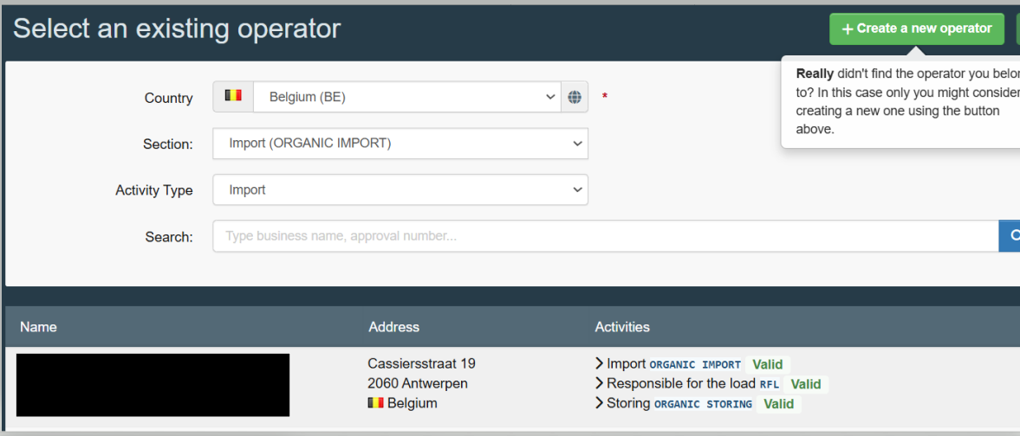
In this case, select the adequate operator and tick the box on the right after which you will need to click on ‘Request Authorisation’ which will create a pop-up notification requesting you to confirm your choice and optionally provide additional information for your request:
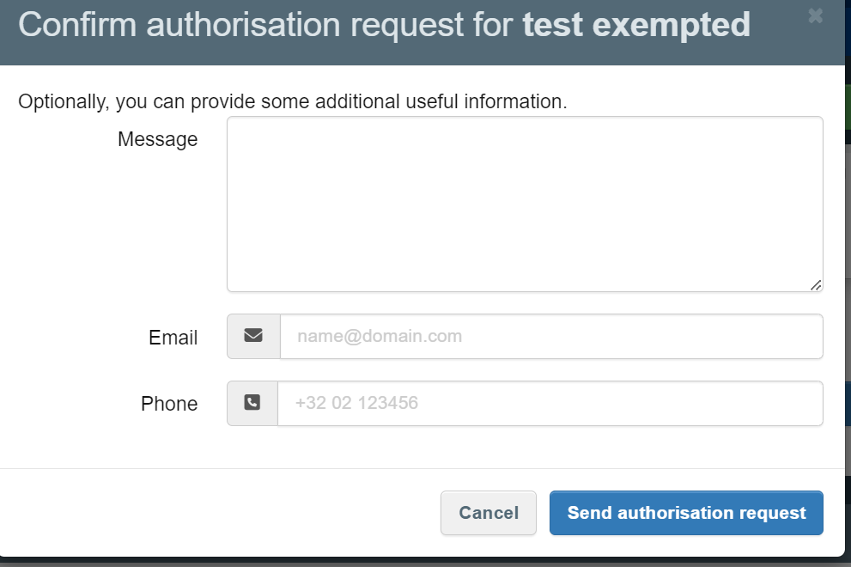

After you have sent the notification, you will be again redirected to the starting page and the following message will appear:
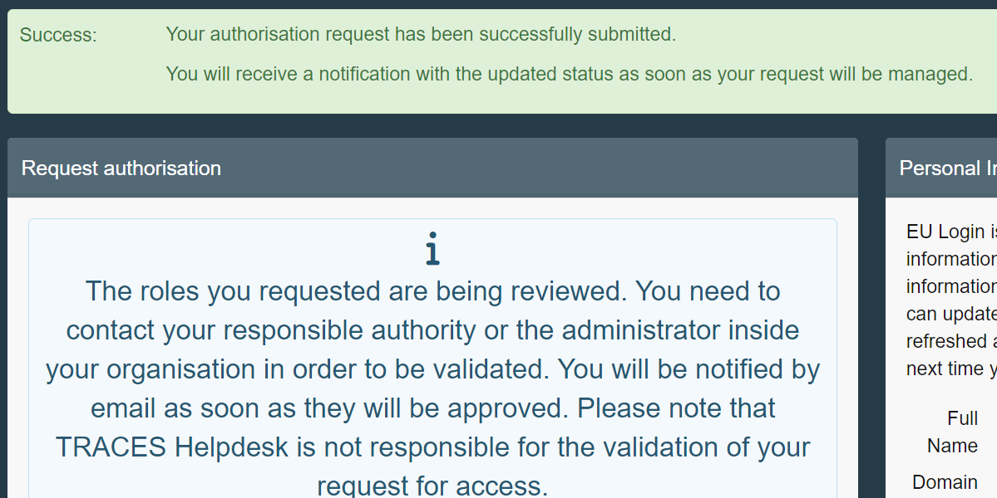 :
Or, as the pop-up message stipulates, if you really did not find an existing operator or you are sure they are not yet registered in the system, you have the option to create one on the spot by clicking on ‘+ Create a new Operator’.
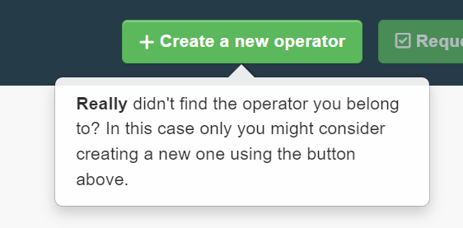

Once you have clicked on the button ‘+ Create a new Operator’, you shall be redirected to an empty operator page where you can fill out the details of the operator as well as the activities you wish to request for this operator:
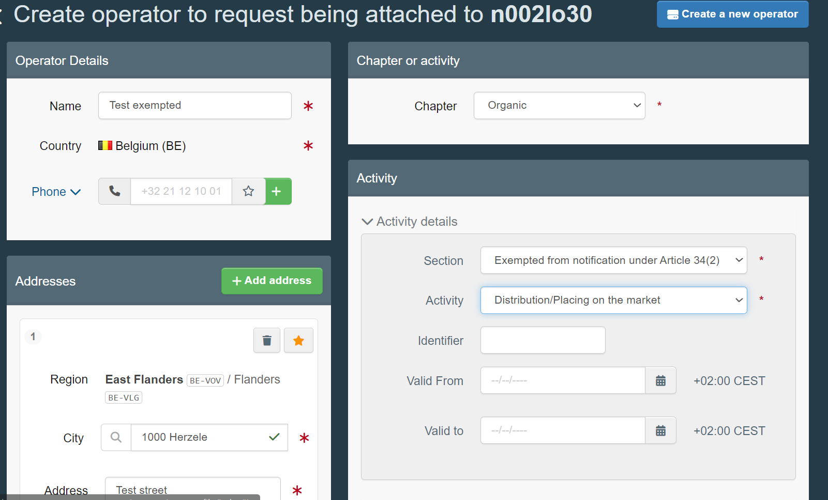
Or
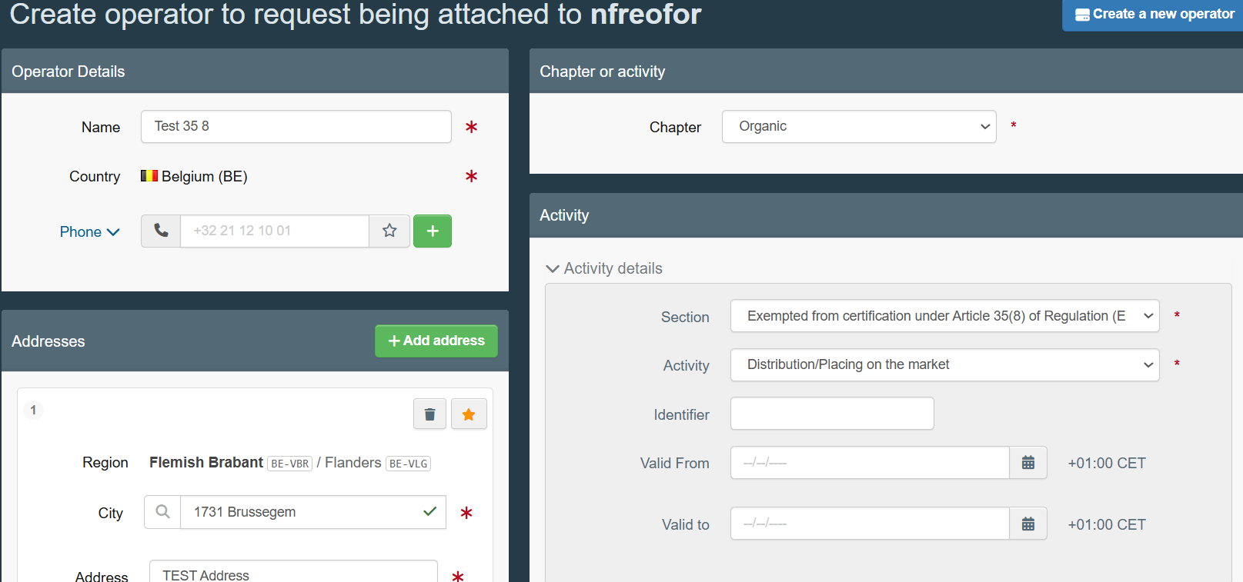

Once the information has been filled end the creation by clicking on ‘Create a new operator’.
The same pop-up will appear:
After you send the notification, you will be again redirected to the starting page and the following message will appear:
:

Accessing and creating your List of Favorite certificates.
This option is available for Operators Exempted from certification or notification under Article 35(8) and/or 34(2) of Regulation (EU) 2018/848 as well as Operators with Certified activities.

Once your user request will have been validated, the dashboard will appear:
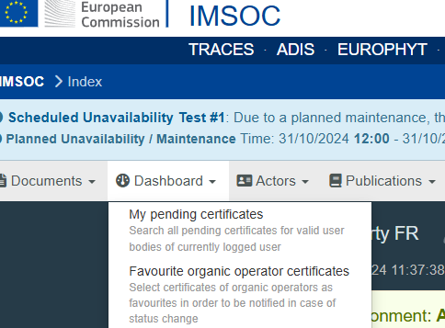
Therein you can access your pending certificates as well as your list of favourite Organic Operator Certificates.
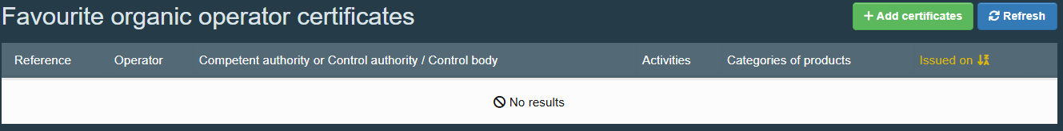

You can add certificates to your lists as shown below:
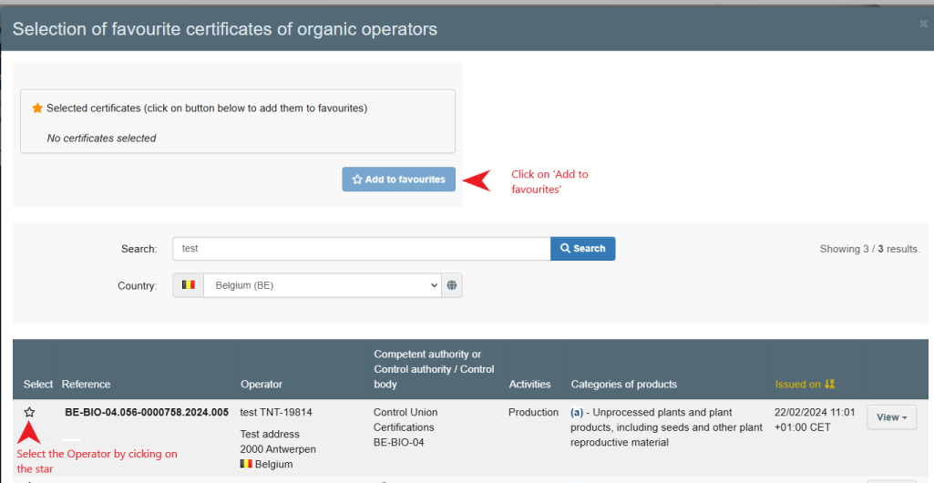

The Certificate will then appear directly in your list of favourite certificates:
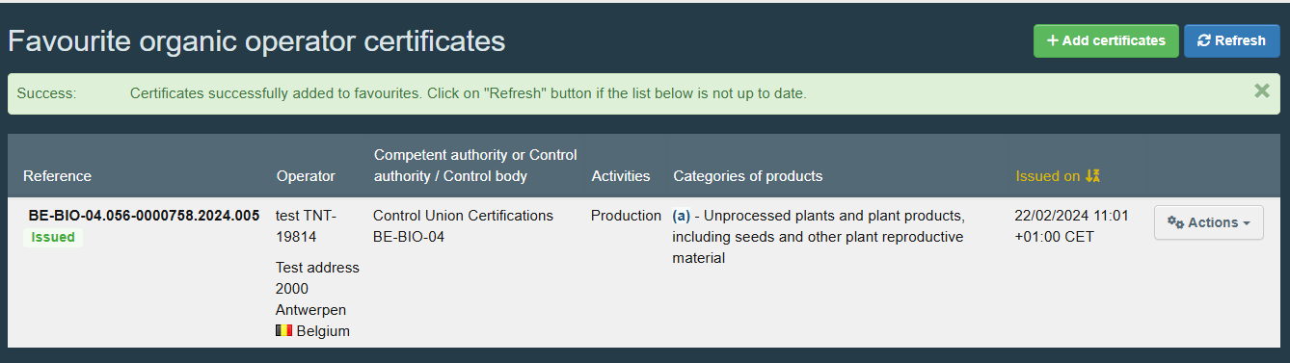

From the button ‘Actions’ you can access the PDF and the Digitally signed version as well as remove any unwanted certificates:

